**LARGE LANGUAGE MODELS AND LANGCHAIN4J**

# Artificial Intelligence (AI)

**Artificial Intelligence (AI)** is a field of computer science focused on creating systems capable of performing tasks that would typically require human intelligence. These tasks include decision-making, visual perception, speech recognition, language translation, and natural language understanding. The development of AI has moved from rule-based systems in the early days to data-driven approaches, particularly machine learning and deep learning.

One of the most significant advancements in AI in recent years is the rise of **Large Language Models (LLMs)**. These are deep learning models trained on vast amount of text data, allowing them to generate, translate, summarize, and reason over human language with impressive accuracy and coherence. LLMs such as **OpenAI’s GPT-4**, **Google’s PaLM**, and **Meta’s LLaMA** exemplify the power of transformer-based architectures.

## Applications of Artificial Intelligence

Artificial Intelligence is no longer limited to academic research or niche applications. Today, AI technologies are deeply embedded in various industries and everyday services, transforming how humans interact with machines and digital systems. Some of the most important applications are:

1. **Natural Language Processing (NLP)** – NLP is a subfield of AI focused on enabling computers to understand, generate and interpret human language. NLP is commonly used in:

* Chatbots and virtual assistants – Use LLM-s to engage in conversations, answer questions and perform tasks. The most popular examples are Siri, Alexa and ChatGPT.
* Machine translation systems – Translate text between languages using deep learning models (Google Translate).
* Text summarization and question answering – Commonly used in customer service and market analysis.

1. **Computer Vision** – Computer Vision enables machines to interpret and analyse visual data. Use cases include:

* Facial recognition – used in security and smartphone unlocking systems.
* Autonomous vehicles – rely on traffic sign recognition and object detection.
* Medical imaging – assisting doctors in recognising diseases such as cancer and pneumonia.

1. **Robotics and Automation** – AI enhances robotics by aiding in decision making scenarios and real time control. It is extensively used in industrial robots operating in a manufacturing line, medical robots assisting surgeons with operations requiring razor sharp precision.
2. **Predictive Analytics** – Predictive analytics uses historical data to forecast future events. It is commonly used in finance and healthcare sectors to predict stock market trends or asses patient risk.

## Artificial Intelligence Techniques

Artificial Intelligence uses a variety of techniques that enable machines to perceive, learn, reason, and act. These techniques can be categorized based on their learning paradigms, reasoning capabilities, and the tasks they are designed to perform.

### Machine Learning (ML)

Machine Learning is a subset of AI that focuses on building systems that learn from data as opposed to being explicitly programmed. The term *machine learning* was coined in 1959 by Arthur Samuel, an IBM employee and pioneer in the field of computer gaming and artificial intelligence. Machine learning approaches are traditionally divided into four broad categories, which correspond to learning paradigms.

1. **Supervised learning** – in supervised learning models are trained on labelled datasets, each input has a corresponding output. Common algorithms are: Linear Regression, Decision Trees and Neural Networks. It is commonly used in image classification and medical analysis.
2. **Unsupervised learning** – deals with unlabeled data, model tries to find hidden patterns or groupings in data. Common algorithms are: K-Means Clustering, Hierarchical Clustering and Principal Component Analysis. Mostly used in anomaly detection and customer segmentation in marketing.
3. **Semi-Supervised learning** – combines small amount of labeled data with a large amount of unlabeled data. Used in facial recognition systems.
4. **Reinforcement Learning** - An agent learns by interacting with an environment. It receives feedback in the form of rewards or penalties and learns to take actions that maximize long-term rewards. Commonly used in robotics and game AI.

### Deep Learning (DL)

Deep learning is a subset of Machine learning that focuses on utilizing multi-layered neural networks to perform tasks such as classification, regression and representational learning. Key architectures:

1. **Convolutional Neural Networks (CNNs)** – used for image processing.
2. **Recurrent Neural Networks (RNNs) and** **Long Short-Term Memory (LSTM)** - used for time series and natural language.
3. **Transformers** - used in language models like BERT, GPT, etc.

Deep learning is used in speech recognition (Siri, Google Assistant), Autonomous driving and Language models.

### Natural Language Processing (NLP)

Subfield of computer science that focuses on enabling machines to understand, generate and interpret human language. Natural language processing has its roots in the 1950s.[[1]](https://en.wikipedia.org/wiki/Natural_language_processing#cite_note-1) Already in 1950, Alan Turing published an article titled "Computing Machinery and Intelligence" which proposed what is now called the Turing test as a criterion of intelligence. It is used in chatbots, machine translation and document summarization.

### Computer Vision

Computer vision is a field that deals with how computers can be made to gain understanding from images or videos. It uses techniques such as: image classification, object detection, and facial recognition. It is used in security systems, autonomous vehicles and medical image analysis.

# Large Language Models

Large language models (LLMs) are cutting edge advancement in the field of artificial intelligence and natural language processing. They are designed understand, generate and manipulate human language in a way that was previously not possible. LLMs are based on deep learning, in particular the Transformer architecture which revolutionized the field of NLP.

Unlike earlier language models, which relied on smaller datasets and were trained with limited context windows, LLMs are trained on a large amount of text sourced from books, websites, and other digital documents. These models typically contain **billions (or even trillions) of parameters**.

The primary task of LLMs is to predict the next word in a sequence, but this at first glance simple task leads to emergence of sophisticated language understanding and generating ability. That means LLMs can summarize texts, write code, answer questions etc.

The key strength of LLMs is the ability to generalize. By learning from vast amount of different texts, they develop understanding of grammar, reasoning patterns, facts about the world and they can even recognise metaphors or humour.

Despite their remarkable capabilities, LLMs also come with limitations. They can produce **hallucinations**, confident but incorrect outputs and may struggle with **logical reasoning, factual accuracy,** or **bias** inherited from training data. Additionally, training and running LLMs requires significant computational resources.

## Evolution of Language Models

The development of language models has gone through several important phases. Early systems were **rule-based**, relying on hand-crafted grammar rules to process language, which were rigid and difficult to scale. These gave way to **statistical models**, such as **n-gram models**, which estimate the probability of a word given the previous few words.

Later, models like **Hidden Markov Models (HMMs)** brought probabilistic modeling into sequence prediction, often used in part-of-speech tagging and speech recognition. However, these still had limitations in capturing context.

The next step forward came with **word embeddings** such as GloVe and Word2Vec, which allowed words to be represented as dense vectors capturing semantic meaning based on usage context. This enabled more nuanced understanding of language and served as the foundation for neural-based models.

Eventually, **Recurrent Neural Networks (RNNs)** and **Long Short-Term Memory (LSTM)** networks enabled modeling longer sequences but were difficult to train on very large texts. The introduction of the **Transformer architecture** in 2017 marked a turning point, enabling efficient parallel training and improved performance on NLP tasks. All modern LLMs are built on Transformer architecture.

## Transformer Architecture

Transformer is a deep learning architecture developed by researchers at Google and is based on the multi-head attention mechanism, which was proposed in the 2017 paper **"Attention is all you need"**. Text is converted to numerical representations called tokens, and each token is converted into a vector via lookup from a word embedding table. At each layer, each token is then contextualized within the scope of the context window with other (unmasked) tokens via a parallel multi-head attention mechanism, allowing the signal for key tokens to be amplified and less important tokens to be diminished.

The original Transformer consists of two main components: the **encoder**, which processes the input data, and the **decoder**, which generates output. In models like BERT, only the encoder is used (for understanding tasks), while models like GPT use only the decoder (for generation). Full encoder-decoder models like T5 and BART are used for tasks such as translation or summarization.

Transformers scale well because they can efficiently model long-range dependencies and leverage large datasets through parallel computation, particularly on GPUs. Positional encodings are added to maintain order information since the architecture itself does not inherently model sequence position. The architecture is the backbone of modern LLMs, enabling them to capture complex language patterns and perform multiple tasks with minimal task specific tuning.

## LLM Training

Training LLMs is a complex process involving **pretraining** and sometimes **fine-tuning**. Pretraining includes feeding LLM with massive amount of data, from Wikipedia articles, textbooks to online forums. That means LLMs can learn language patterns by predicting the next token in sequence or filling in masked words.

After pretraining, a model can be **fine-tuned** on specific tasks or domains, improving performance in targeted applications.

Challenges include managing **computational costs**, ensuring **data quality**, and handling **ethical concerns** related to the training data.

## LLM Capabilities

LLMs have demonstrated a large range of capabilities that make them adaptable across various industries and tasks. One of the most common applications is **text generation**. LLMs can compose various styles of text like poems, essays and professional emails. The generated content often mimics human-like fluency and tone, making these models useful for both creative and formal writing tasks.

Another key application is **question answering**, where LLMs can answer to both factual and contextual queries. In some benchmarks, their performance has surpassed that of specialized question-answering systems, showcasing their ability to understand and retrieve relevant information from a prompt or embedded context.

LLMs also excel in **summarization**, effectively condensing large bodies of text into concise and informative summaries. This is particularly useful in contexts such as legal documentation, academic research, or news aggregation.

In the field of **translation**, LLMs have high accuracy in multilingual tasks. They are capable of translating text between many languages while preserving meaning, tone, and context.

Another important capability is **code generation** where models such as Codex and GPT-4 can write, explain, and even debug code snippets in multiple programming languages. These models assist developers by providing autocomplete suggestions, generating boilerplate code, and helping with logic implementation.

Finally, LLMs demonstrate strong performance in **few-shot and zero-shot learning**. This means they can perform new tasks with minimal or even no explicit training examples, simply by interpreting instructions or patterns provided in the input prompt. This flexibility is one of the reasons why prompt engineering has become a crucial skill in effectively deploying LLMs.

Overall, the versatility of LLMs makes them valuable across a range of domains, including healthcare, law, education, and software engineering, among many others. As these capabilities continue to evolve, LLMs are becoming integral tools in both research and industry.

## Limitations and Challenges of LLMs

Despite their impressive capabilities, LLMs come with notable limitations. One key issue is their tendency to produce "hallucinations” which means confidently generating information that is factually incorrect, due to their reliance on statistical patterns. Additionally, these models often reflect biases found in their training data, which can lead to inappropriate or skewed outputs, particularly in sensitive contexts.

Another limitation lies in their **contextual memory**. Most LLMs operate within a fixed context window, which constrains their ability to handle very long documents or sustain extended reasoning across a conversation. Moreover, the **interpretability** of LLMs remains an open challenge, as their internal workings are complex and opaque, making it difficult to explain specific outputs or decisions.

Ethical and legal concerns also persist. Questions about misuse, data privacy, and copyright infringement continue to surface, especially as these models are increasingly adopted in real-world applications. Addressing these challenges is essential to ensure that LLMs are developed and used responsibly.

## Popular LLMs

The rapid advancement of large language models has led to the development of several leading systems, each pushing the boundaries of what artificial intelligence can achieve in natural language understanding and generation. Among the most influential is **GPT-4**, developed by OpenAI. GPT-4 is a powerful general-purpose model that excels in tasks requiring reasoning, creativity, and conversational fluency. It serves as the backbone of applications like ChatGPT and is widely used in education, content creation, customer support, and more. Its ability to generate coherent and contextually appropriate responses has made it one of the most recognized LLMs globally.

Another influential model is **Claude**, developed by Anthropic. Unlike many other models, Claude is designed with a strong emphasis on alignment, safety, and ethical behaviour. Named after Claude Shannon, this model focuses on being helpful, harmless, and honest. It is built to reduce the risk of harmful outputs and is trained with a method called constitutional AI, which guides its behaviour through a set of principles. Claude is seen as a significant step forward in developing more controllable and reliable AI systems.

**PaLM**, created by Google DeepMind, represents Google’s entry into high-capacity LLMs. PaLM has been integrated into applications such as Bard and various Google Workspace tools. It is known for its broad skillset, which includes coding, translation, and even basic reasoning tasks.

Meta’s contribution to the LLM landscape is the **LLaMA** series (Large Language Model Meta AI). LLaMA models are distinct in that Meta has released them with open-weight licensing, making them widely accessible for academic and research use. The second generation, **LLaMA 2**, has been optimized for fine-tuning and deployment in more constrained environments, such as edge devices or smaller cloud instances. This openness has fueled a large community of developers and researchers to experiment with and adapt the models for a variety of tasks.

Another significant model is **Gemini**, the successor of previously mentioned PaLM. Gemini is a multimodal model, capable of processing not only text but also images and potentially other forms of input, integrating them seamlessly in a single interaction. This makes it especially powerful for tasks that require understanding and reasoning across different media types. Gemini represent Google´s move to human like AI interactions.

Each of these models, GPT-4, Claude, PaLM, LLaMA, and Gemini bring unique strengths and priorities to the AI ecosystem. While GPT-4 emphasizes general-purpose usability and broad accessibility through APIs, Claude prioritizes safety and alignment. PaLM and Gemini focus on integration with Google’s ecosystem and multimodality, and LLaMA supports openness and research flexibility.

# LangChain4j

As LLMs are becoming more and more popular and central to modern applications, many frameworks have emerged to make it easier for developers to integrate LLMs into real world systems. One such framework is **LangChain**, originally created in Python and JavaScript, designed to streamline the process of building LLM-powered applications by combining models with external data, tools, and memory. **LangChain4j** brings this powerful framework to the Java ecosystem, allowing Java developers to leverage LLMs in their own applications without switching languages.

Langchain4j is particularly significant in enterprise settings, where Java remains a dominant technology. By offering a familiar, object-oriented API, Langchain4j simplifies interaction with LLMs like OpenAI's GPT, Ollama, and others. It also supports modular development of agents, tools, memory, prompt templates, and document retrieval systems.

## Architecture and Design

LangChain4j is built with a modular architecture that mirrors the structure of the original LangChain framework, bringing powerful LLM tooling into the Java ecosystem. Its design is centered on flexibility, composability, and clean abstraction. Each module, ranging from LLM integration to memory, agents, and retrievers is designed to operate independently or in coordination with others, making it easy to build complex LLM applications with minimal code duplication. This modularity is especially beneficial for enterprise developers accustomed to frameworks like Spring, as LangChain4j uses common Java patterns such as dependency injection and fluent builders to create and connect components.

At the heart of Langchain4j are several key building blocks: **LLM interfaces**, **prompts**, **memory**, **chains**, **agents**, **tools**, and **retrievers**. Each plays a distinct role in orchestrating how a language model interacts with users, tools, and external knowledge.

The **LLM interfaces** serve as unified entry points to various language model providers. These interfaces abstract away differences between models like OpenAI's GPT-4, Hugging Face-hosted models or locally deployed models via Ollama. This allows developers to switch providers or support multiple backends with minimal changes to their codebase.

**Prompts** are central to directing the behaviour of language models. Rather than hard-coding query strings, Langchain4j uses prompt templates, which can include placeholders for dynamic variables. This approach promotes code reuse, reduces duplication, and simplifies the process of tuning prompts during development. Templates help ensure consistent interactions, especially in production-grade applications where precision is vital.

**Memory** enables applications to maintain state across multiple turns in a conversation. In stateless systems, each LLM query is handled in isolation, but memory allows for continuity, where past interactions can inform future responses. Langchain4j supports both short-term memory and long-term memory, enabling applications like chatbots, personal assistants, or report generators to maintain a coherent dialog history.

**Chains** are sequences of operations that combine language models, prompts, and memory into cohesive workflows. For example, a chain might retrieve documents, summarize them with an LLM, and then pass the summary to another chain for classification. By linking components together, developers can construct multi-step pipelines.

**Agents** in Langchain4j introduce a layer of autonomous decision-making. Rather than following a predefined sequence, agents interpret user input and dynamically choose which tools or actions to invoke, based on the model’s reasoning. This approach enables more intelligent and interactive applications, such as digital assistants that can book appointments, fetch real-time data, or analyze documents.

**Tools** are user-defined functions that an agent can call to perform specific actions. These might include web search, API calls, database lookups, or even code execution. Tools are registered with descriptive metadata so that the LLM can decide when and how to use them.

Finally, **retrievers** are components responsible for fetching relevant information from external sources which are often unstructured text documents.

Together, these components form the backbone of Langchain4j. By integrating them in a modular and reusable way, developers can build sophisticated LLM applications in Java while maintaining clean code and scalability.

## LLM Integration in Java

LangChain4j simplifies the process of integrating large language models into Java applications by providing client abstractions for a variety of LLM providers. These clients wrap the necessary HTTP calls, API keys, and request/response formatting behind easy-to-use interfaces, enabling developers to focus on functionality rather than connectivity.

One of the most commonly used integrations is the **OpenAIClient**, which allows applications to interact with OpenAI’s suite of models, including ChatGPT, GPT-4, and GPT-3.5. By specifying the model name and API key, developers can quickly begin sending prompts and receiving completions from OpenAI’s cloud-based infrastructure.

For developers seeking full control the best option is **OllamaClient** which offers a bridge to local models like Mistral and LLaMA or other models running through Ollama. This is particularly useful for teams working with sensitive data or constrained by internet access, as it allows for deploying and querying models entirely on local hardware.

Langchain4j also includes support for hosted models on platforms like Hugging Face through the **HuggingFaceClient**. This client enables seamless access to thousands of open-source models in various domains, including natural language understanding, classification, translation, and more. Developers can specify which hosted model to use by its repository ID and authenticate using Hugging Face tokens.

In addition, there is a **LocalModelClient**, designed for situations where developers expose LLMs through their own RESTful APIs. This flexible option allows integration with custom deployments.

A key strength of Langchain4j is that switching between these providers requires minimal code changes. Since each client adheres to the same interface, developers can inject different LLM implementations depending on the environment, use case, or performance constraints. This pluggable design makes Langchain4j adaptable to both experimentation and production.

## Prompt Engineering and Templates

One of the most defining features in LangChain4j is its support of **prompt templates,** which enable Java developers to construct flexible and dynamic prompts for large language models. Rather than hardcoding static text, prompt templates allow you to inject variables and structure into the prompt, improving both **reusability** and **readability** while reducing errors during development.

**Prompt engineering** is a fundamental technique when working with LLMs because the phrasing, structure, and context of a prompt significantly influence the model's output. Langchain4j embraces this concept by allowing developers to define prompts as templates with placeholders, which are filled at runtime. This approach simplifies experimentation and tuning, making it easier to iterate on prompt wording and context without rewriting large blocks of code.

### Basic Example

Here is a simple example of using a PromptTemplate in Langchain4j:

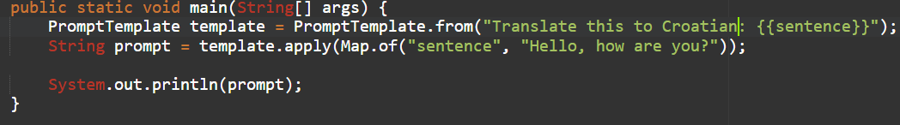

In this case, {{sentence}} is a placeholder that is dynamically replaced with the provided input. This template can then be passed to an LLM for translation. Reusing the same structure with different sentences is straightforward, making this an ideal approach for localization tasks.

### Multi Variable Templates

Langchain4j supports templates with multiple variables. For example:

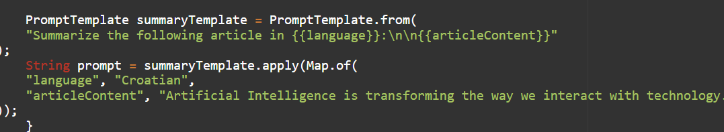

Output would be:

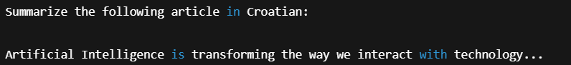

This flexibility is especially useful for **multilingual applications** (e.g., translation, localization tools) and **parameter-based generation** (e.g., changing tone, length).

### Use with Chains

A **Chain** in Langchain4j is a reusable flow made up of several components:

* Prompt templates - building model input
* LLM clients – generate responses
* Memory – retain context
* Tools or retrievers – fetch information

Langchain4j chains are analogous to pipelines where each element transforms the input/output or enriches it. Basic example:

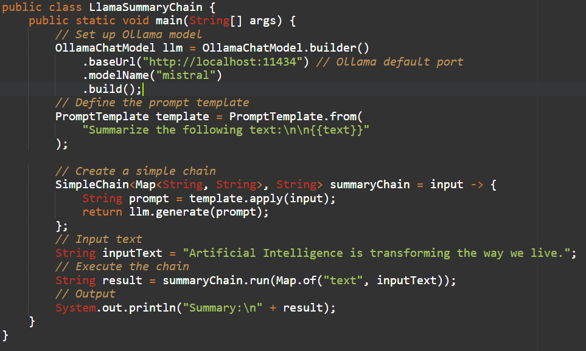

By separating **template logic** from **model invocation**, we get easier unit testing, reusability across different chain stages, swappable components.

### Conditional and Dynamic Prompt Selection

While Langchain4j templates themselves are static, it is possible to **dynamically select** and **compose** them based on logic in your Java code. Basic example:

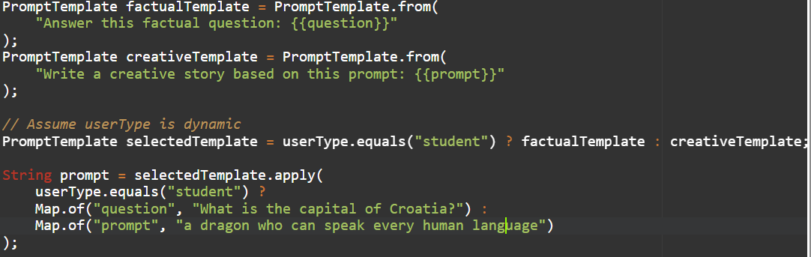

This approach is commonly used in role-based applications, content filtering and user personalization.

## Memory and Stateful Chat in LangChain4j

Langchain4j enables **stateful interactions** by integrating memory components that help track past messages, enabling coherent multi-turn conversations. This is crucial for building **AI assistants, helpdesk bots**, or **domain-specific chat agents** that need to remember user context.

There are two types of memory: short-term memory and long-term memory.

### Short-Term Memory (In-Memory)

It is suitable for per-session conversations. It lives only during the lifecycle of the application or session and it is fast and easy to use. Basic example:

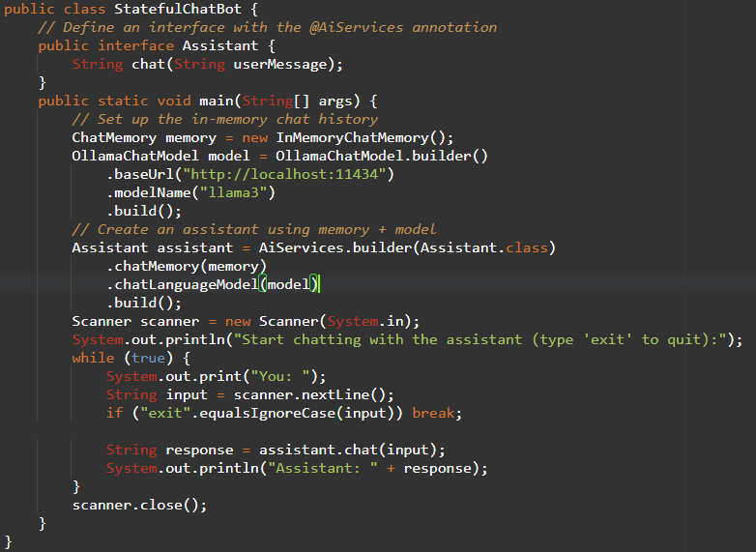

In the example above, the InMemoryChatMemory stores all previous user and assistant messages. Langchain4j automatically includes past messages in each prompt so that the LLM can generate context-aware responses. The assistant is built from an annotated interface (Assistant) using the AiServices factory.

### Long-Term Memory

Long-term memory in Langchain4j plays a critical role in creating intelligent, stateful applications that can retain knowledge across sessions and adapt to user behaviour over time. Unlike short-term memory, which is typically confined to a single interaction or session, long-term memory persists data in external systems such as databases, file systems, or vector stores. This allows applications powered by LLMs to recall relevant information from previous interactions, remember user preferences, or retrieve facts from a document corpus which makes them far more useful, especially in real-world scenarios.

Langchain4j provides a flexible interface for implementing long-term memory. Developers can create custom memory modules by persisting user messages and assistant responses in relational databases like PostgreSQL, NoSQL stores, or even flat files. This makes it possible for an LLM-powered application to "remember" user’s past inputs and responses.

Another powerful use of long-term memory is in the form of vector-based retrieval systems. Langchain4j supports integration with vector databases such as Chroma, Weaviate, Pinecone, or Qdrant, which store embedded document representations in a high-dimensional space. Developers can preprocess and index domain-specific documents into these vector stores by converting their content into numerical embeddings using models like Mistral or LLaMA via Ollama.

This architecture is often used in **Retrieval-Augmented Generation (RAG**) pipelines, where the retrieval mechanism provides context to the language model, dramatically improving reliability and reducing hallucinations.